

# Introduction to Racial Equity Module

# Participant’s Guide

V 2.0 September 2021

Table of Contents

Introduction to Racial Equity Module 1

Participant’s Guide 1

Introduction 3

Course Description 3

Module Overview 3

Introduction Video Link 3

Racial Healing Framework 3

Pillar 1: Uncovering History 5

History of Orange County and CSUF 6

Demographic Data 6

Racial demographics of orange county over time 7

Racial demographics of CSUF students over time 8

Racial demographics of CSUF faculty over time 9

Minority Serving Institution (MSI) 10

Pillar 2: Making Connections 12

Understanding the Self: Identity Wheel 13

Wheel of Oppression and Privilege Reflection 15

Relation to Others: Bias 16

Pillar 3: Working Toward Healing 18

Other Racial Equity Issues – Definitions 19

Racial Equity Issues: Structural Inequality 19

Racial Equity Issues: Power Dynamics 20

Racial Equity Issues: Privilege 21

Racial Equity Issues: Microaggression 22

Pillar 4: Taking Action 23

Personal Action- Reflection Activity 24

Appendix 25

Appendix A: Resources 25

Appendix B: Glossary of Terms 28

Introduction to Racial Equity Module 32

## Introduction

### Course Description

The Introduction to Racial Equity module is a 60-minute module that will allow participants to better understand racial equity, particularly as it relates CSUF, through the lens of history, self-awareness, and interpersonal relationships. The curriculum was developed by a task force representing faculty, staff, and student voices to ensure that the content is relevant and impactful for all members of our campus community.

### Module Overview

Once you’ve completed e-learning module, you will have…

* a working definition of racial equity and racial healing
* a greater awareness of racial equity issues at CSUF
* a better understanding of how your role connects to creating a more inclusive campus climate

### Introduction Video Link

[Racism vs Anti-racism Ibram X. Kendi](https://www.youtube.com/watch?time_continue=110&v=_OXMgA0Fwsk&feature=emb_logo)

### Racial Healing Framework

During the e-learning module, we use the Racial Healing Framework (shown on the following page). This framework is based on [Truth, Racial Healing & Transformation (TRHT)](https://healourcommunities.org/).

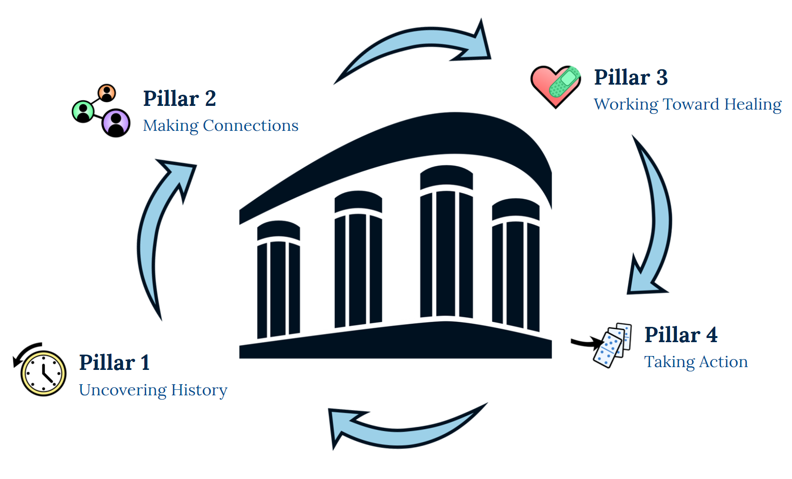

## Pillar 1: Uncovering History



Research, acknowledge, and share personal, family, community, and societal histories pertaining to race and race relations

### History of Orange County and CSUF

Here are some additional resources to learn more about the information shared during the e-learning module:

[A Brief History of Ku Klux Klan in Orange County](https://fullertonobserver.com/2019/01/07/a-brief-history-of-the-ku-klux-klan-in-orange-county-notes-on-the-banality-of-evil/)

[Sundown Towns in Orange County](https://blog.lareviewofbooks.org/essays/sundown-towns-orange-county/)

[BSU Townhall Daily Titan Article](https://dailytitan.com/2019/10/black-student-union-demands-change/)

[Vandalism Daily Titan Article](https://dailytitan.com/2018/11/csuf-vandalized-anti-semitic-graffiti/)

[OC Human Relations Hate Crime Reports](https://www.ochumanrelations.org/hatecrime/hate-crime-reports/)

### Demographic Data

The data on the following pages provide historical, racial/ethnic demographics of Orange County and CSU Fullerton students, faculty, and staff/administrators. Please keep in mind that the data and the racial/ethnic categories have some limitations. Additional demographic data are available at the [CSU Fullerton Institutional Research website](http://www.fullerton.edu/data/institutionalresearch/).

### Racial demographics of orange county over time

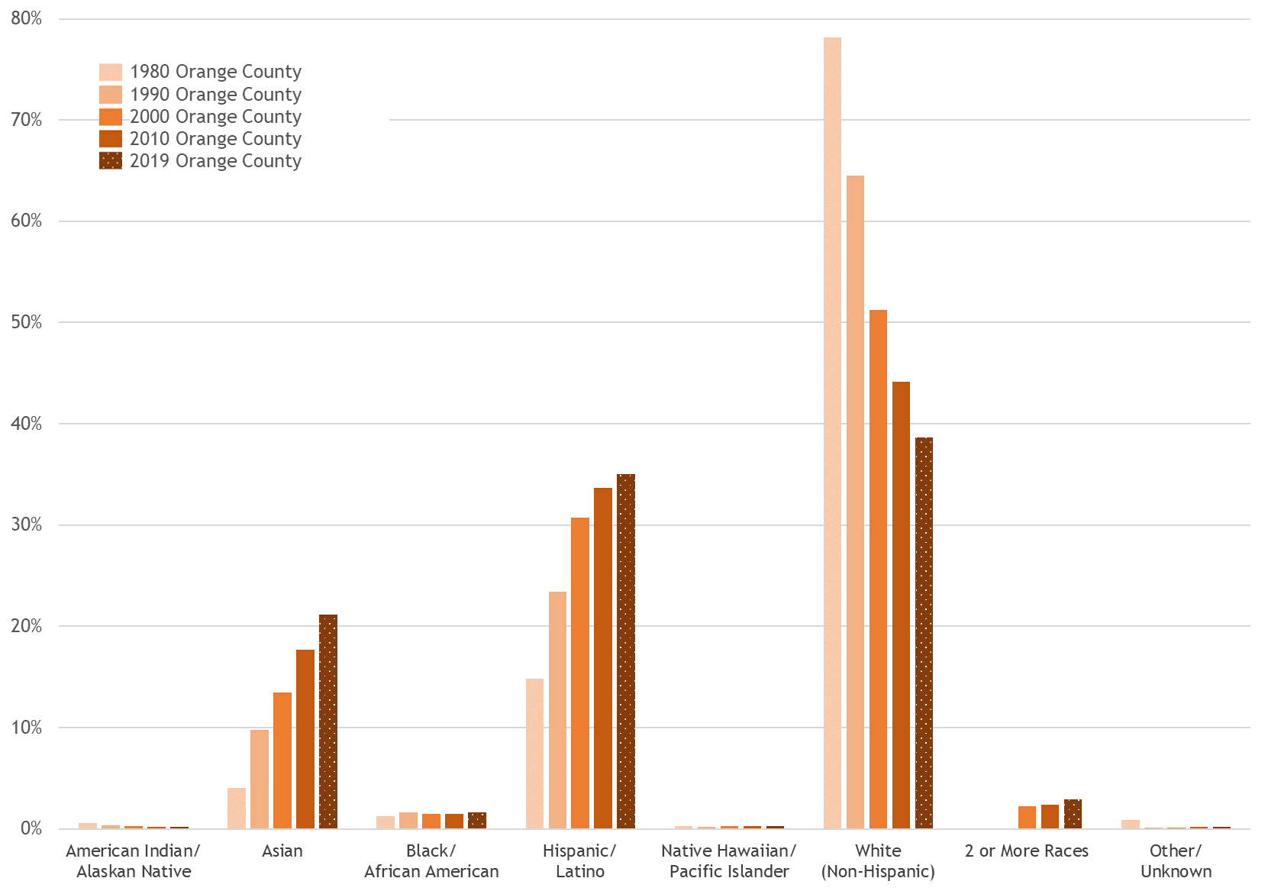

### Racial demographics of CSUF students over time

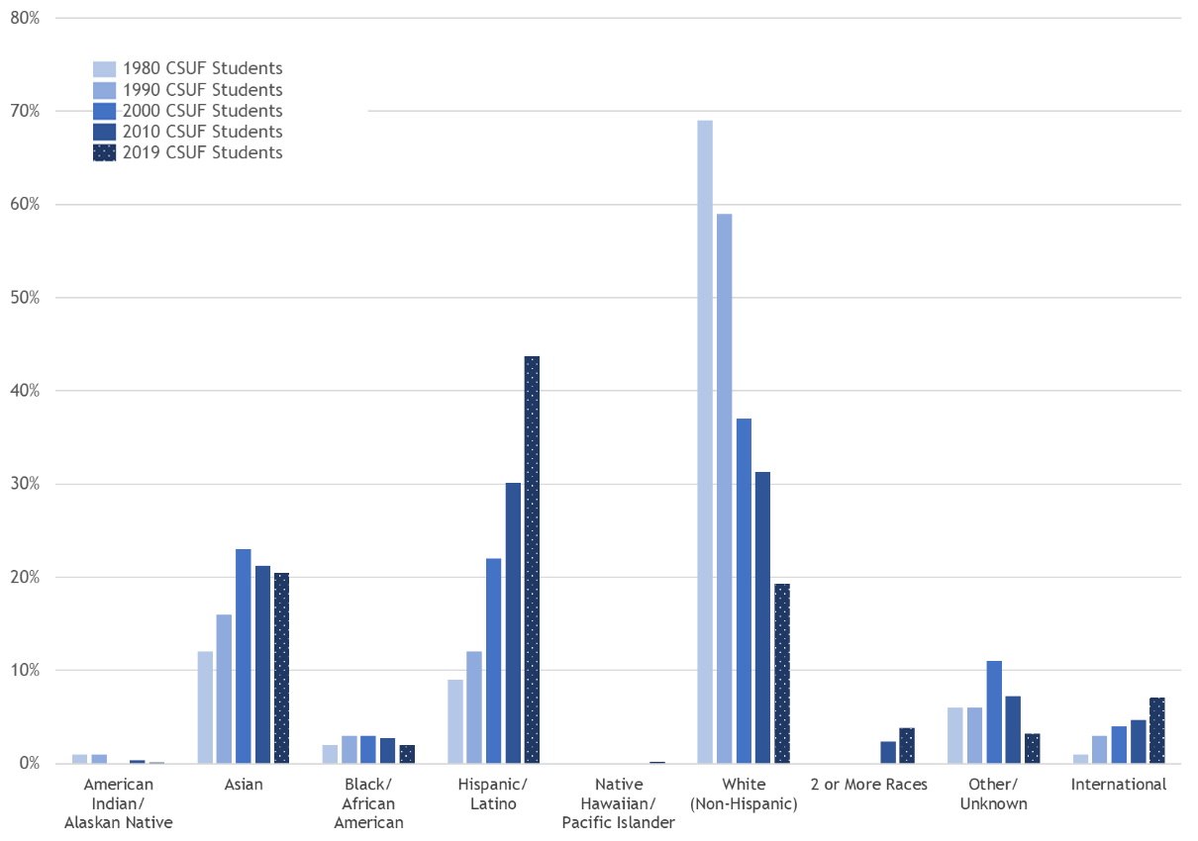

### Racial demographics of CSUF faculty over time

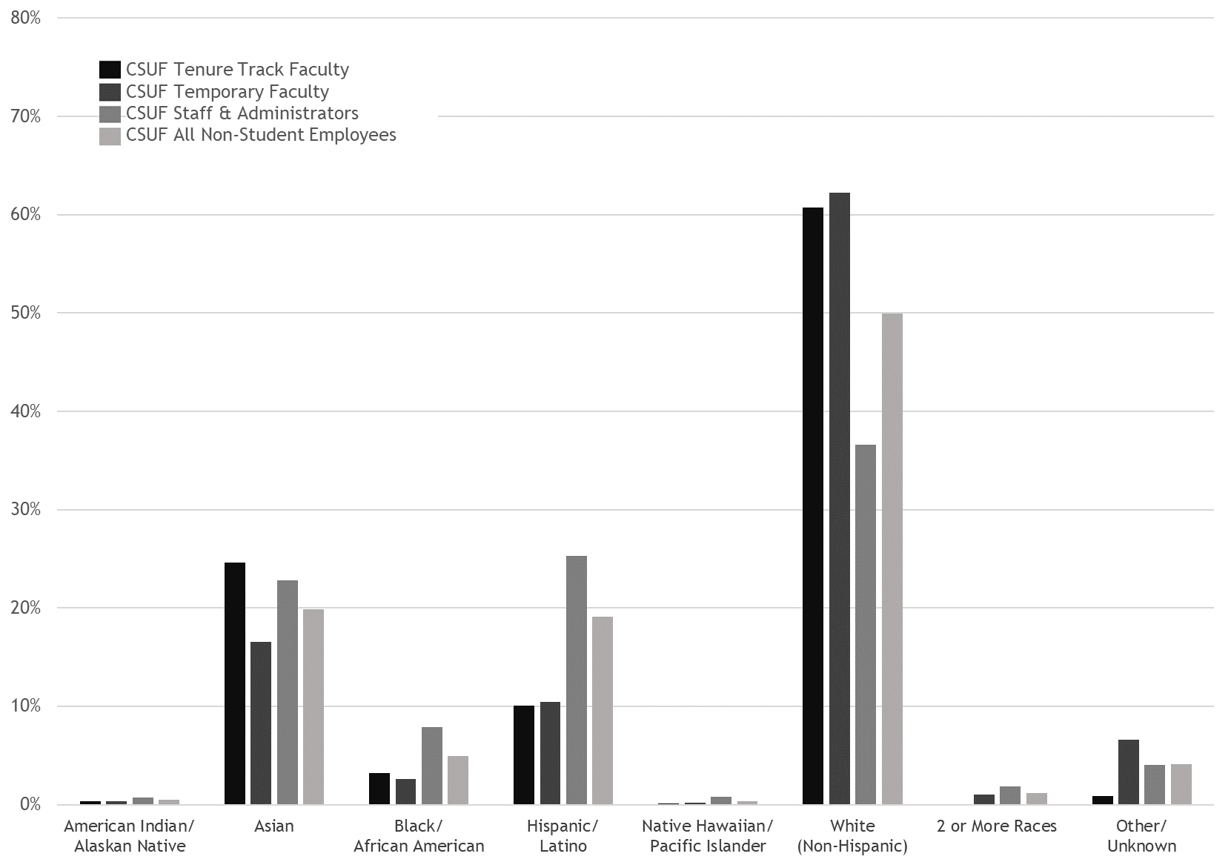

### Minority Serving Institution (MSI)

Minority Serving Institutions (MSIs) are institutions of higher education that serve minority populations. There are four official designations for MSIs:

**Historically Black Colleges and Universities (HBCUs)**

An HBCU is any historically black college or university that was established prior to 1964, whose principal mission was, and is, the education of black Americans, and that is accredited by a nationally recognized accrediting agency or association. HBCUs include 91 four-year and 17 two-year institutions. The majority of the 102 HBCUs are located in the Southeastern states. They comprise 3% of America’s institutions of higher education yet enroll 16% of all African-American students in higher education and award 24% of all baccalaureate degrees earned by African-Americans nationwide.

**Hispanic-Serving Institutions (HSIs)**

HSIs are accredited, post-secondary, higher educational institutions with at least 25% total full-time enrollment of Hispanic undergraduate students. HSIs included four-year and two-year, public and private educational institutions. HSIs enroll 40% of all Hispanic-American students of higher education. There are 274 institutions of higher education defined as HSIs using the criteria defined by the White House Initiative and the Department of Education. CSU Fullerton has been designated as a minority serving institution and has the designation as a Hispanic-Serving Institution.

**Tribal Colleges and Universities (TCUs)**

The first TCU was created on a remote reservation community on the Navajo Nation. They now exist throughout Native American land. The 35 public and private higher educational institutions provide a response to the higher education needs of Native Americans, and generally serve geographically-isolated populations that have no other means of accessing education beyond the high school level. TCUs have become increasingly important in the educational opportunity for Native American students, an importance they have achieved in a relatively brief period of time.

**Asian American and Native American Pacific Islander-Serving Institution (AANAPISI)**

AANAPISIs are institutions that serve an undergraduate population that is both low income (at least 50% receiving Title IV needs-based assistance) and in which Asian American or Native American Pacific Islander students constitute at least 10% of the student body. The AANAPI community is one of the fastest growing populations in the U.S. Projections indicate that, by 2050, this population will double in size. As a result, the education of AANAPIs will be critical in achieving the educational goals of the U.S. The current, official designation for CSU Fullerton is as an HSI. CSU Fullerton also meets the criteria as an AANAPISI.

## Pillar 2: Making Connections

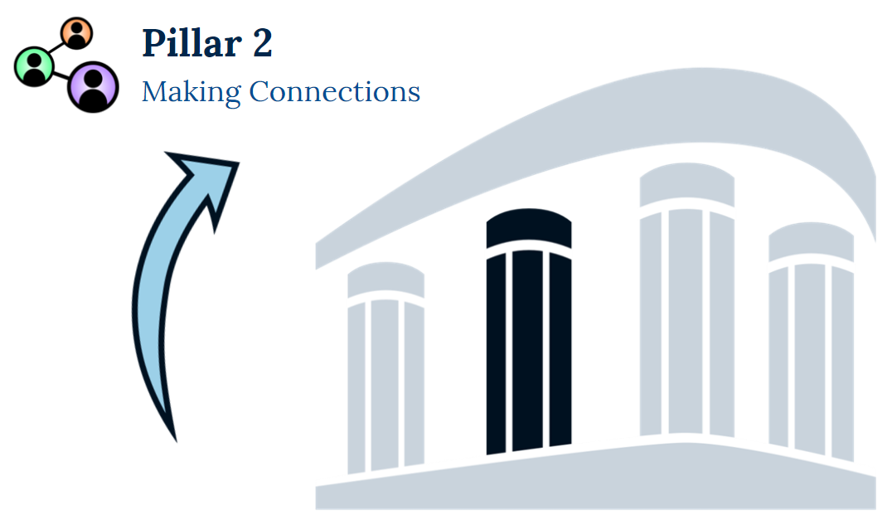

Connect with others within and across racial lines, and build authentic and accountable relationships

### Understanding the Self: Identity Wheel

The Racial Healing Framework wheel below shows various identities on a series of spectrum lines. The identity labels at either end of each line (e.g. Christian and Non-Christian) represent differing identities, as defined by our society. A person can identify anywhere along the spectrum line for each identity pairing. For example, if your dad is German and Irish, and your mom is Mexican, and you grew up with your mom’s side of the family, you might identify on the White Person / Person of Color spectrum where the grey dot is shown.

**Instructions (for next page):**

For each line, draw a dot that indicates where your personal identity is based on the spectrum between the identity categories.

**Identity Wheel**

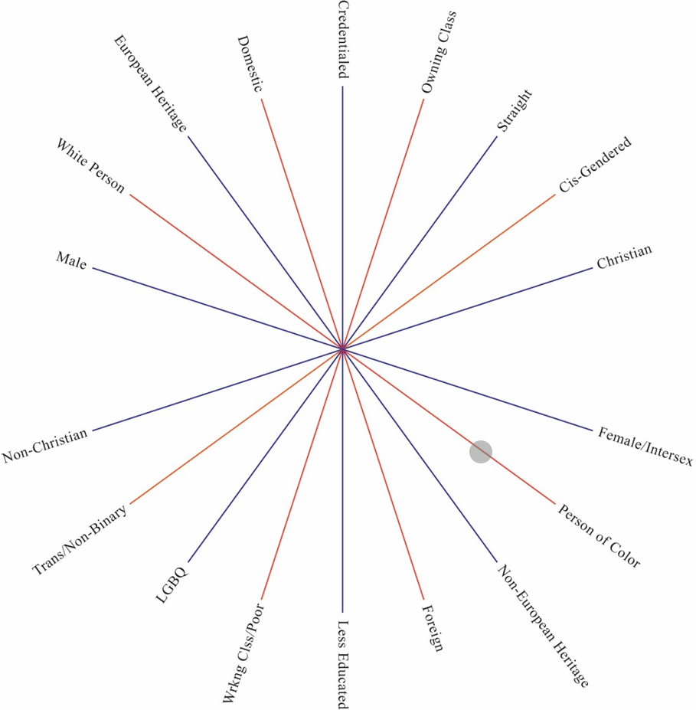

### identity category spectrum with privilege above and oppression belowWheel of Oppression and Privilege Reflection

**Reflection Questions:**

1. How many of your identity dots fall above the Privilege-Oppression line?
2. How many of your identity dots fall below the line?
3. How do your areas of privilege and areas of oppression shape your life experiences and world views?

### Relation to Others: Bias

**Bias**

* A prejudice in favor of or against one thing, person, or group compared with another
* Favorable bias: “Everyone from my town is fantastic”
* Unfavorable bias: “Everyone from that generation is lazy”

**Impact of Bias**

* a natural habit of the mind that helps us understand the world around us
* Social categorization is linked to bias
* Social categorization, bias, stereotypes, and generalizations can impact our interactions
* Bias can lead to discrimination
* Bias can make certain prejudices automatic

**Types of Bias**

* Bias can be explicit or implicit
* Explicit: “My office always asks my Asian co-workers to figure out the math issues in the budget”
* Implicit: “This candidate earned their degree from an Ivy league, so they must be the most qualified for the job”

## Pillar 3: Working Toward Healing

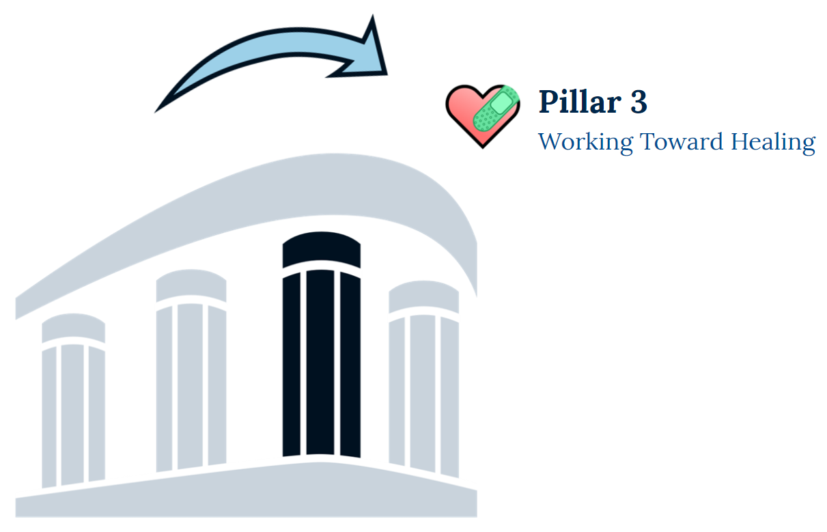

Explore how we can heal together, utilizing different approaches.

### Other Racial Equity Issues – Definitions

**Structural Inequality -** The systemic disadvantage of one social group compared to other groups with whom they coexist as a result of policy, law, governance, and culture.

**Power Dynamics -** The ability to direct and influence behavior, events, and allocation of resources.

**Privilege -** A special advantage that is granted, but not earned, through an explicit or implicit status or rank and is exercised for the benefit of the recipient to the exclusion, detriment, or oppression of others.

**Microaggression -** A statement, action, or incident regarded as an instance of indirect, subtle, or unintentional discrimination against members of a marginalized group such as a racial or ethnic minority.

### Racial Equity Issues: Structural Inequality

Everyone in my department is talking about self-care. One of my colleagues was talking about the importance of exercise the other day. They are a runner and shared that during the summer, they really enjoy taking Zumba classes or running in the neighborhood park trail after dinner. They say it’s quiet, breezy, and they feel “one with nature.” I didn’t say anything about exercise and doing outdoor activities. As a racial minority, I’m always on high alert when I walk around. On a run a few years ago, I was stopped by the cops and questioned because they didn’t think I “belonged” in that neighborhood—MY neighborhood. Ever since, I’ve been wary of outdoor exercise routines.

**Questions**

1. How does this scenario illustration structural inequality?
2. What can be done differently to mitigate structural inequality in this scenario?

### Racial Equity Issues: Power Dynamics

During a department meeting, everyone is discussing ways to engage racial minority students on campus and the different programming and supports our unit can develop and offer. A White senior supervisor said, “well, I feel bad about the White students on campus. I think they have it bad sometimes because we don’t develop any programs for them and don’t really pay attention to them anymore.” When others in the meeting bring up the topic of White privilege, the White senior supervisor becomes angry and starts talking about their family history fleeing Germany during WWII, and that they grew up poor, and not all White people are privileged. The other people in the room don’t feel comfortable talking after that and don’t feel comfortable addressing this issue any further.

**Questions**

1. How does this scenario illustration power dynamics?
2. What can be done differently to mitigate power dynamics in this scenario?

### Racial Equity Issues: Privilege

I recently started a new job and my colleagues have all been talking about our division’s annual holiday party. Everybody seems so excited and talked about how their families all really enjoyed it as well. As a gay Muslim man, I was hesitant about what my new colleagues would think if I brought my husband to the party. Also, at my last institution, a holiday party really meant we celebrated Christmas and I spent all night explaining to my colleagues my faith and relationship. It became too exhausting, we just stopped going. I don’t know if I want start that process again.

**Questions**

1. How does this scenario illustration privilege?
2. What can be done differently to mitigate privilege in this scenario?

### Racial Equity Issues: Microaggression

I am Asian-American. I was born and raised in Houston, Texas. Recently, I had an interaction with a co-worker while we were working on a project together that left me feeling frustrated. At the end of the meeting they said, “I am very impressed with how fast you are picking up the process and procedures. You also speak English so well without any accent. Where are you from?” I responded, “I am from Houston.” They asked further, “but what’s your nationality?” I didn’t know how to respond. This isn’t the first time that someone has said that to me.

**Questions**

1. How does this scenario illustration microaggressions?
2. What can be done differently to mitigate microaggressions in this scenario?

## Pillar 4: Taking Action



Actively champion systemic and structural change throughout our society and in all aspects of life to support equality, justice, and healing for all

### Personal Action- Reflection Activity

**Reflection Question**

How can we use what we’ve heard and learned today to contribute to creating a more inclusive CSUF?

**Brainstorm Activity**

What are some actions that you are willing to do to make CSUF a more inclusive and racially equitable place? This week, this month, this semester, this year? Write down a specific action you are willing to commit to doing

## Appendix

### Appendix A: Resources

**Campus Resources**

* [Center for Scholars (Foster Friendly Ally Training)](https://www.fullerton.edu/guardianscholars/resources/ffa.php)
* [Disability Support Services (DSS Ally Training)](http://www.fullerton.edu/dss/)
* [Diversity, Inclusion and Equity Programs (DIEP)](https://hr.fullerton.edu/diep/)
* [Diversity Initiatives and Resource Center](http://www.fullerton.edu/dirc/)
* [African American Resource Center](http://www.fullerton.edu/aarc/)
* [Asian Pacific American Resource Center](http://www.fullerton.edu/aparc/)
* [Latinx Resource Center](http://www.fullerton.edu/lcrc/)
* [LGBTQ Resource Center (LGBTQ Ally Training)](https://www.fullerton.edu/lgbtq/)
* [Titan Dreamers Resource Center (UndocuAlly Training)](http://www.fullerton.edu/tdrc/)
* [Diversity Initiatives & Resource Centers Allyship Trainings](https://www.fullerton.edu/dirc/educational-opportunities/Ally-Training.php)
* [Employee Assistance Program](https://hr.fullerton.edu/total-wellness/eap/)
* [Faculty Development Center (FDC)](https://fdc.fullerton.edu/)
* [Faculty and Staff Associations (FSAs)](https://hr.fullerton.edu/diep/faculty-staff-associations.php)
* [Asian American and Pacific Islander Faculty and Staff Association](http://www.fullerton.edu/aapifsa/)
* [Black Faculty and Staff Association](http://www.fullerton.edu/bfsa/)
* [Chicano/Latino Faculty and Staff Association](http://www.fullerton.edu/clfsa/)
* [Faculty & Staff Pride Alliance](http://www.fullerton.edu/pridealliance/)
* [Researchers and Critical Educations (RACE)](http://ed.fullerton.edu/race/)
* [Veterans Staff and Faculty Association](http://www.fullerton.edu/vsfa/)
* [Undocumented and Allies Faculty and Staff Association (see webpage bottom for contact information)](https://hr.fullerton.edu/diep/faculty-staff-associations.php)
* [The Lawrence de Graaf Center for Oral and Public History](https://coph.fullerton.edu/collections/communitycollection.php)
* [Male Success Initiatives](https://www.fullerton.edu/msi/)
* [Veterans Resource Center (Vet Net Ally Training)](http://www.fullerton.edu/veterans/)
* [WoMen’s and Adult Reentry Center](http://www.fullerton.edu/womenscenter/)

**DIRC**

Diversity Initiatives & Resource Centers (DIRC) creates engagement opportunities that empower, educate, and activate students in the areas of social justice, equity, and anti-racism. We support students by building communities that foster a sense of belonging, challenging students to engage in critical inquiry, and serving as a hub for resources in inclusive and affirming spaces. DIRC was established in 2014 and comprises five identity-based resource centers: the African American Resource Center (AARC), the Asian Pacific American Resource Center (APARC), the Latinx Community Resource Center (LCRC), the LGBT Queer Resource Center (LGBTQRC) and the Titan Dreamers Resource Center (TDRC). Professional and student staff in the department and within each center work through a student-centered lens to create inclusive spaces for students to be their authentic selves and co-curricular learning opportunities for students to develop deeper understanding of their identities and those of others.

**Ethnic Studies Departments**

[Chicana and Chicano Studies](http://hss.fullerton.edu/chicano/)

[African American Studies](http://hss.fullerton.edu/african-american/)

[Asian American Studies](http://hss.fullerton.edu/asian-american/)

[Latin American Studies](http://hss.fullerton.edu/latinamerican/)

**Additional Resources**

[Orange County Human Relations](https://www.ochumanrelations.org/)

[Diversity Inclusion Equity Programs](https://hr.fullerton.edu/diep/)

[Titans Together](http://together.fullerton.edu/)

[CSUF Faculty and Staff Associations](https://hr.fullerton.edu/diep/faculty-staff-associations.php)

[Intersectionality Video](https://www.youtube.com/watch?v=ViDtnfQ9FHc&ab_channel=NationalAssociationofIndependentSchools%28NAIS%29)

### Appendix B: Glossary of Terms

**Anti-racism**

The policy or practice of opposing racism and promoting racial tolerance.

**Bias**

A prejudice in favor or against one thing, person, or group compared with another.

**Cultural Identity**

A person's self-conception and their self-perception as it relates to ethnicity, race, religion, sexual orientation, disability status, or any other kind of social group.

**Diversity**

A description of all the ways in which people differ, including the various identities and characteristics that make one individual or group different from another. It is all-inclusive and recognizes everyone and every group as part of the diversity that is valued at Cal State Fullerton. A broad definition includes not only race, ethnicity, and gender — the groups that most often come to mind when the term “diversity” is used — but also age, national origin, religion, disability, sexual orientation, gender identity and expression, socioeconomic status, education, marital status, language, physical appearance, and a variety of other identities. It also involves different ideas, perspectives, and values.

**E-learning**

The delivery of educational content through electronic or digital means.

**Equity**

The guarantee of fair treatment, access, opportunity, and advancement for all students, faculty, and staff, while at the same time striving to identify and eliminate barriers that have prevented the full participation of some groups due to oppression, marginalization, and minoritization. The principle of equity acknowledges that there are historically underserved and underrepresented populations, and that fairness in the context of these unbalanced conditions is needed to assist equality in the provision of effective opportunities to all groups.

**Ethnicity**

The fact or state of belonging to a social group that has a common national or cultural tradition.

**Inclusion**

A respectful way of creating value from the differences of all members of our community, in order to leverage talent and foster both individual and organizational excellence.

**Intersectionality**

The interconnected nature of social categorizations such as race, class, and gender as they apply to a given individual or group, regarded as creating overlapping and interdependent systems of discrimination or disadvantage.

**Latinx**

A person of Latin American origin or descent (used as a gender-neutral or nonbinary alternative to Latino or Latina).

**Microaggression**

A statement, action, or incident regarded as an instance of indirect, subtle, or unintentional discrimination against members of a marginalized group such as a racial or ethnic minority.

**Minoritization**

The status of a group and its members relative to the socially dominant group.

**Power** **Dynamics**

The ability to direct and influence behavior, events, and allocation of resources.

**Privilege**

A special advantage that is granted, but not earned, through an explicit or implicit status or rank and is exercised for the benefit of the recipient to the exclusion, detriment, or oppression of others.

**Race**

A grouping of people based on shared physical or social qualities into categories generally viewed as distinct by society.

**Racial** **Healing**

A process for facilitating trust and building authentic relationships that bridge the divides created by real and perceived racial differences between and among people and communities. To heal is to restore to wholeness, to repair damage, and to set right. Healing a societal racial divide requires recognition of the need to acknowledge the wrongs of the past, while addressing the consequences of those wrongs.

**Social Categorization**

The process by which people categorize themselves and others into differentiated groups; a natural habit of the mind that helps us understand the world around us.

**Structural Inequality**

The systemic disadvantage of one social group compared to other groups with whom they coexist as a result of policy, law, governance, and culture.

**White Fragility**

Discomfort and defensiveness on the part of a white person when confronted by information about racial inequality and injustice. In this state, even a minimum amount of racial stress becomes intolerable, triggering a range of defensive thoughts and behaviors.

Thank you for participating in the

## Introduction to Racial Equity Module

Your feedback is important to ensure the quality and relevance of this module.

Please complete the module evaluation at your earliest convenience.

For more information on the Titans Together Initiative,

please visit the [Titans Together website](http://together.fullerton.edu/).

To request this training for your office/department/organization,

please submit a [training request form.](http://fullerton.qualtrics.com/jfe/form/SV_6s3p5Zr4lwItZJ3)